Game concept document:

Holy warrior quest

Summary:

Game concept:

Introduction

Context

Gender

Station

Game mechanics:

Game mechanics

Game mode

Different displacements

Game flow

Different characters

Collectible object

Gameplay element

Game physics and statistical:

Displacements

Damages and healing

General physics of the game

IA characteristics

User interfaces:

HUD

Organizational chart

Sound design:

Sound effect

Music

Narrative design

Story of the game

Level Design:

Level design

Level structure

Game concept:

Introduction:

Holy warrior quest is a Zelda like game, where the player takes control of Enanatuna, by walking and using a spell of fire. Her objective is to complete the labyrinth of Manat and become a holy warrior for the goddess.

Context:

The game, based in the universe of Aladdin, is addressed for all the player and mostly for Zelda like fan’s

Gender:

Holy warrior quest is a 2D RPG with horizontal and vertical scrolling, where the exploration took an important place.

Station:

The game is exclusively on computer, with control on the keyboard or with a gamepad.

Game mechanics:

Game mechanics:

While you move on the screen, the camera will follow the character. The map is divided on two maps, the desert and the labyrinth, for accessing the second one, you have to push two button defend by monster in the desert.

Arrived in the labyrinth, you will have to find your way to the statue of Manat by defeating the monster.

Game mode:

There is only one game mode, for a single player.

Different displacements:

There are four different displacements:

* the right direction’s showing the right side of the character on the screen.
* The left direction shows the left side of the character.
* The down direction’s showing the front side of the character.
* The upper direction shows the back side of the character.

Game flow:

Different characters:

Hero:

Called Enanatuna, young women which can use some magic to defeat monster.

NPC:

Shamash Nasir, is a vendor who sells magic book for learning new spell.

Nutesh, is the guard of the temple of Manat.

Faely, is a little spirit, captured by local monster, who will help Enanatuna, if she deliver her.

Collectible object:

The player will collect:

* Life potion,
* Mana potion
* coins

Gameplay element:

Game physics and statistical:

Displacements:

Damages and healing:

General physics of the game:

IA characteristics:

User interfaces:

HUD

* Life bar
* Mana bar
* Small map

Organizational chart

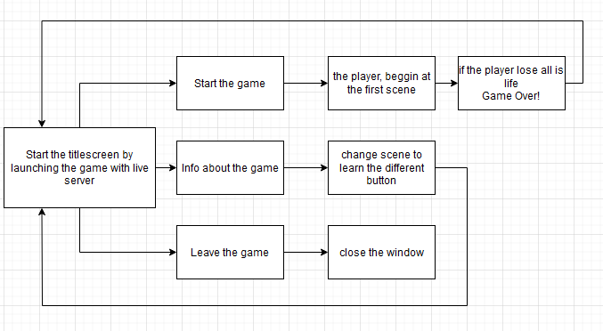

Sound design:

Sound effect

Music

Level Design:

Level design

Level structure

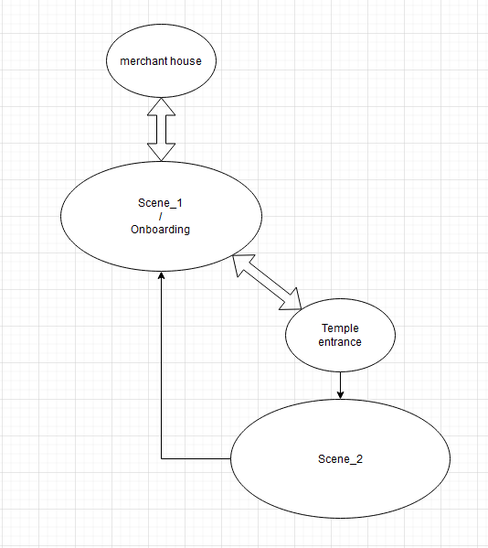

experience and intentions:

The player is embedded in desertic land, where he will fight monsters for accessing two buttons, that will open the door for the labyrinth of the temple.

Synopsis:

Enanatuna, is a young woman, who want to become a holy warrior of Manat. For realizing this, she need to find the way to enter the temple of the goddess. But a lot of people find the end of their destiny.

Will you find your way ? or your destiny ?

CFLC:

|  |  |  |  |
| --- | --- | --- | --- |
| Holy warrior’s quest | | | |
| Cible | Lieu | Finalité | Cognition |
| All kind of public  /  Fan de Zelda-Like | On computer | Embed the player in an Middle East universe, making him discover a nabatean’s divinity | Make the player improve himself finding the way to exit the labyrinth |
| Resolving the opening of the labyrinth  Fighting monsters  Resolving the labyrinth  Fighting the boss  Praying behing the statue | | | |

Boucle OCR :

Tétrade :

Synthèse Tétrade :

Moodboard :

